

**Porter’s Pure PNW**

**Pure Genius - Organic Strawberry Beer**

**Communication Plan**

**Team Pure Genius**

**Shannon Connant**

**Cecilia Garcia**

**Skyler Gonsalves**

**Erica Meier**

**TABLE OF CONTENTS**

Project Definition

Project Charter

Stakeholder Register

Interpersonal Skills

Management Skills

Communication Technology

Communication Management

Performance Reports

Information Distribution Tools

Issue Log

Decision Log

Change Requests

Variance Analysis

Appendix

# Project Charter

Project Charter is a document issued by the project initiator or sponsor that formally authorizes the existence of a project, and provides the project manager with the authority to apply organizational resources to project activities. It can provide information about internal and external parties involved in and affected by the project, such as project sponsor(s), customers, team members, groups and departments participating in the project, and other people or organizations affected by the project.

The competition in the US organic market is strong and dynamic. Porter’s Pure PNW will expand their products lines by introducing a strawberry beer into the organic market. PNW believes that the new organic beer will pay off the investment and generate a sustainable growth. This new product will improve the customer experience by introducing new flavors base on urban customer’s needs with a particular emphasis on organic benefits. This beer will keep Porter’s standards for quality and community.

The leadership team decided to take advantage of the different levels of partnerships with local farms, commercial agreements with suppliers and community insolvent to support their expansion strategy.

The project charter will be presented during the committee kick-off meeting.

# Stakeholder Register

Stakeholder Register contains all details related to the identified stakeholders including but not limited to identification information (name, org position, location, role, contact info), assessment information (major requirements, main expectations, potential influence in the project, phase in the life cycle with the most interest) and stakeholder classification (internal/external, supporter/neutral/resistor, etc).

The Stakeholder Register will be distributed at the first project kick-off meeting to make sure we have current contact information and that the register is complete. A soft copy of the register will be uploaded to a team SharePoint site so that all internal stakeholders can access and information can be kept up to date, as needed.

Stakeholder Register

# 

# Interpersonal Skills

Interpersonal Skills: Effective project managers acquire a balance of technical, interpersonal, and conceptual skills that help them analyze situations and interact appropriately.

The project manager must have the necessary skills to effectively communicate with both internal stakeholders (project team, project sponsors, executives, etc.) and external stakeholders (suppliers, consultants, and clients). He/she must also have the skills necessary to bring both inside and outside parties together as partners with a common goal.

The project manager will keep an open door policy to all stakeholders to allow for open communication and to foster positive relations between all parties involved in the project. The open door policy will be communicated to the committee at the kick-off meeting. This policy will encourage feedback and motivate the team to work cohesively.

The project manager will follow the organizations policies and procedures when developing communication protocol within and outside the project team.

As shown in table below, important interpersonal skills are leadership, team building, motivation, communication, influencing, decision making, political and cultural awareness and negotiation.

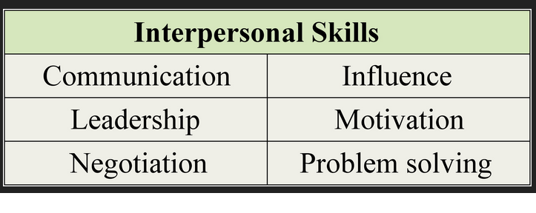

# Management Skills

Management Skills used by the project manager include but are not limited to presentation skills, negotiating, writing skills and public speaking.

Management skills will be critical as the project manager directs to each task and meets each milestone of the project. He/she will be responsible for following up with stakeholders (committee members, executives, volunteers, etc.) to set clear expectations for the management style, decision making style and direction of the project.

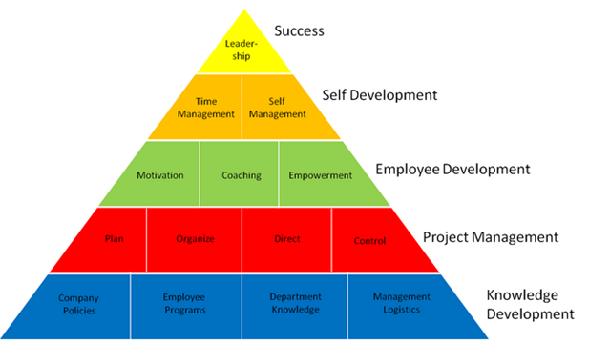

# Communication Technology

Communication Technology is the methods used to transfer information among project stakeholders and it can vary significantly based on the urgency of the need for information, the availability of technology, expected project staffing, duration of the project and the project environment.

A variety of technological/virtual sources will be utilized for the new product development planning process. The type of information being transferred and the level of team members and stakeholders involved will determine the source of communication technology needed. Communication sources will include:

* Internal communications:
  + Email
  + Skype
  + SharePoint
  + Webex/video conferencing
  + Cell phones
  + Texting
  + Portable radios (used day of event)
* External/stakeholder communications:
  + In-person meetings
  + Email
  + Skype
  + Phone calls
  + Website
  + Email distribution system

Prior to the implementation of these tools, we must ensure that all team members are adequately trained in each technology.

* Not all stakeholders and team members know how to operate Webex, for instance, and we know that that this form of communication will be used often throughout the event planning. It is our responsible to ensure all individuals are trained and comfortable with using Webex.

# Communication Management

Communication Management plan is the document that describes: the communications needs and expectations for the project; how and in what format information will be communicated; and when and where each communication will be made; and who is responsible for providing each type of communication. The communication management plan is contained in, or is a subsidiary plan of, the project management plan.

As shown in table below, the communication management plan will show stakeholders how the channels of communication will be managed throughout the project life cycle. Project Manager will organize regular meetings to keep communication flow and address any issue that arrive early or during the project. The project manager will also set communications rules, priorities and tools to be used to accomplish project objectives.

The communication during the project will be written, spoken and electronic. Informal project communication should be professional and effective but it has to be documented in order to be considered.

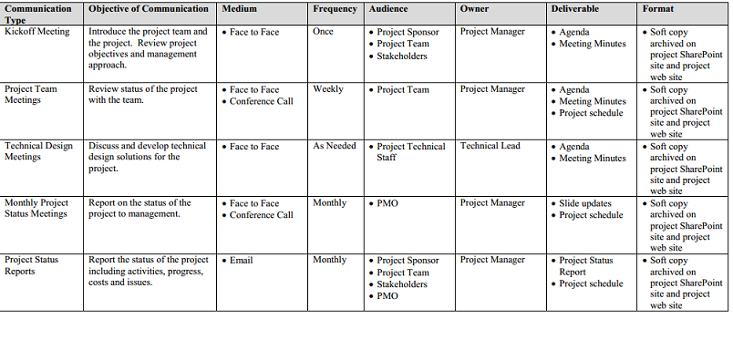

# Performance Reports

Performance Reports are used to distribute project performance and status information, should be made available prior to project meetings, and should be as precise and current as possible.

Performance reports will be shared at project team meetings to show progress on the following topics:

* Status of R&D on new product development and market research
* Review of budget and costs incurred to date
* Review of supply and distribution channels
* Status of product testing in marketplace
* Milestone status updates

# Information Distribution Tools

Information Distribution Tools include hard-copy distribution, manual filing systems, press releases, shared-access electronic databases, electronic communication and conferencing tools.

In an effort to facilitate acceptable communications throughout the project lifecycle, various distribution tools will be utilized to ensure that all stakeholders are kept informed of all aspects of the project from beginning to end.

The following is a list of the distribution tools to be utilized for this project (including responsibility and audience):

|  |  |  |
| --- | --- | --- |
| Distribution Tool | Responsibility | Audience |
| Status Reports(expanded) | Project Manager | Project team (distributed during status meetings) |
| Newsletters (public): | Marketing Manager | All potential consumers and customers |
| Status Reports (brief) | Project Manager | Executive team |
| Newsletters (company) | Marketing Manager | All company employees (project updates) |
| Website | Marketing Manager | All potential users (within and outside of organization |

# Issue Log

Issue Log is a written log documents and helps monitor who is responsible for resolving specific issues by a target date. Issue resolution addresses obstacles that can block the team from achieving its goals and it can be used to facilitate communication and ensure a common understanding of issues.

Issue logs will be kept current by the team and shared at weekly committee meetings. All teams will use a uniform template so that the issue information is clear and concise. Resolutions to those issues can then be discussed at the meeting, if determined the issue will create a roadblock.

One team member will be assigned the task of maintaining the issue log during each committee meeting. This task will be rotated to a new team member each meeting.

Issue Log

# Decision Log

Decision Log is a way for the project manager and the project team to document the decisions made to reduce the chances of a dispute arising from unknown decisions.

* The project manager will maintain a decision log throughout the entire lifecycle of the project.
* Decisions which do not impact the agreed upon scope of the project can be made by the project manager (decisions outside the agreed upon scope of the project will require approval from an executive of the organization).
* The title of the decision log will include the following:
  1. Project Name.
  2. Project Manager.
  3. Revision Date (this date will be revised each time the decision log is changed).
* The body of the decision log will be comprised of the following 5 sections:
  1. Number (represents the number of each decision).
  2. Decision being made (nature of the decision).
  3. Decision status (whether the decision is pending or closed).
  4. Date of decision (indicates the date the the decision was made or closed).
  5. Comments (explanation of the decision or expected date of decision closure).
* Decision Status (explanation):
  1. A decision can be pending or it can be closed.
  2. A pending decision will not include a date of decision (if a decision is listed as pending, the initiation date should be listed under the comment section).
  3. Once a decision has been made, it will be considered closed (the date of closure should be listed under the “Date of Decision”).

Decision Log

# Change Requests

Change Requests are requests to expand or reduce the project scope, modify policies, processes, plans, or procedures, modify costs or budgets, or revise schedules.

When the need for a change to the project scope, timeline, or budget is identified, the following steps should be followed to properly communicate this proposed change to the team:

1. Team lead to fill out a Change Request form (following page) with consensus from the requesting team.

2. Forms can be submitted each week by EOD Thursday

3. Each Friday, the project team will review change requests, determine necessity, and either approve or reject the change. Request team should be available to answer any questions the project team may have regarding the change.

4. During the Monday weekly project committee meeting, project team will discuss the plan to implement approved change requests.

5. Denied/Pending change requests will be followed up on after the meeting between the project team and the requesting team to discuss non-approval decision.

6. Approved change requests will be added to the project plan by EOD each Wednesday.

Change Request Form

# Variance Analysis

Variance Analysis is a method for resolving the total variance in the set of scope, cost, and schedule variables into specific component variances that are associated with defined factors affecting the scope, cost, and schedule variables.

Understanding that Porter’s Pure PNW is launching a new product, it is imperative to analyze the variance between the planned project parameters and the actuals, and to communicate those changes to the team so that the remaining project planning can be reformed (if necessary) to compensate for high/low variance.

1. During each project gateway meeting, the project team will present to stakeholders a cost variance and schedule variance report.

2. The same chart/graph will be used through the project lifespan, so that stakeholders can identify trends and patterns.

3. Based on the information presented in the report, project stakeholders will discuss mitigation plans to decrease project variance for upcoming milestones.

4. At the end of the project, a summary variance analysis report and supporting charts/graphs will be presented to the stakeholders to determine the go/no go decision for continuing to produce the new product based on the overall business impact.

# Appendix

# 

# 

## 

## Stakeholder Register

|  |  |  |  |  |  |  |
| --- | --- | --- | --- | --- | --- | --- |
| **Name of Stakeholder** | **Position** | **Role in Project** | **Type of Stakeholder** | **Expectations/**  **Interests** | **Influence on Project Outcome** | **Contact Information** |
| Shannon  Connant | Operations  Manager | Project  Manager | Internal | Successful development & launch of new product | Influencer | 381-555-1234 |
| Cecilia Garcia | Operations  Manager | Project  Manager | Internal | Successful development & launch of new product | Influencer | 381-555-1233 |
| Skylar Gonsalves | Operations  Manager | Project  Manager | Internal | Successful development & launch of new product | Influencer | 381-555-1232 |
| Erica Meier | Operations  Manager | Project  Manager | Internal | Successful development & launch of new product | Influencer | 381-555-1231 |
| Ethan Porter | Director of Operations & Founder | Sponsor | Internal | Successful development & launch of new product | Influencer | 381-555-1230 |
| Amy Porter | Director of Partner Relations & Founder | Sponsor | Internal | Successful development & launch of new product | Influencer | 381-555-1235 |
| George McMillan | Director of Business Development | Business Develpt | Internal | Successful development & launch of new product | Influencer | 381-555-1236 |
| Bruce  Takagi | Director of Research & Development | R&D | Internal | Successful development & launch of new product | Influencer | 381-555-1237 |
| Ivy | Program Manager, R&D | Assigned R&D lead | Internal | Successful development & launch of new product |  | 381-555-1238 |
| Ellen Jones | Director of Finance | Budget & Finance | Internal | Competitive product margin on new product |  | 381-555-1239 |
| Otto | Sr Operations Manager, Marigold Center | Production | Internal |  |  | 381-555-1210 |
| Manuel | Sr Operations Manager, Sunflower Center | Production | Internal |  |  | 381-555-1211 |
| Jean-Claude | Research Analyst | Product Direction | External |  | Supporter | 381-555-1212 |
| Javier | Market Researcher | Market Analysis | External |  | Supporter | 381-555-1213 |
| Sophia | Organic Certification Specialist | Organic certification | External |  | Supporter | 381-555-1214 |
| Joe | Organic Hops Specialist | Product supplier | External |  | Supplier | 381-555-1215 |
| Jennifer | Organic Barley Malt specialist | Product supplier | External |  | Supplier | 381-555-1216 |
| Edgar | Organic Yeast specialist | Product supplier | External |  | Supplier | 381-555-1217 |
| James | Brew tools supplier | Product supplier | External |  | Supplier | 381-555-1218 |
| Brewstop LLC | Brewing Consultant | Production | External |  | Supporter | 381-555-1219 |
| Mike Brew | Brewmaster | Production | External |  | Supporter | 381-555-1220 |
| First Impressions | PR Agency | Marketing | External |  | Supporter | 381-555-1299 |
| Rob’s Farms | Organic strawberry Farm | Product supplier | External |  | Supplier | 381-555-1221 |
| Wellington Farms | Organic strawberry Farm | Product supplier | External |  | Supplier | 381-555-1222 |
| Wholesome Inc. | Certified organic & RPET Bottling plant | Bottling Plant | External |  | Vendor | 381-555-1223 |
| Whole Foods | Organic food market | Customer | External | New product | Supporter | 4381-555-1224 |
| PCC Market | Organic food market | Customer | External | New product | Supporter | 381-555-1225 |
| Harrison | Professor, Nutrition Science | Advisor | External |  | Supporter | 381-555-1226 |

## 

## Change Request Form

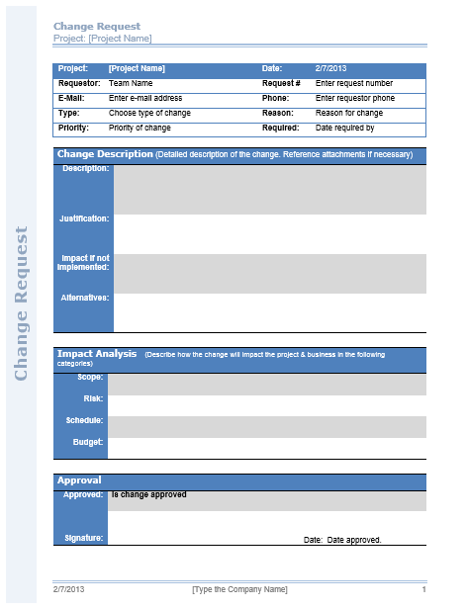

## Issue Log

|  |  |  |  |  |  |  |  |  |
| --- | --- | --- | --- | --- | --- | --- | --- | --- |
| **Project:** |  |  |  |  |  |  | **Date:** |  |
| **Issue** | **Description** | **Priority**  **(H, M, L)** | **Category** | **Reported By** | **Assigned To** | **Status** | **Date Resolved** | **Resolution** |

## Decision Log

Decision Log Format/Template (see below):

|  |  |
| --- | --- |
| **Project Name:** |  |
| **Project Manager:** |  |
| **Revision Date:** |  |

|  |  |  |  |  |
| --- | --- | --- | --- | --- |
| Number | Decision Being Made | Decision Status | Date of Decision | Comments |
| 1 |  |  |  |  |
| 2 |  |  |  |  |
| 3 |  |  |  |  |
| 4 |  |  |  |  |
| 5 |  |  |  |  |
| 6 |  |  |  |  |